MSU Extension’s Six-Step Community Change Model

Step 1: Identify the Need

Step 1 Guide: Identify the Need

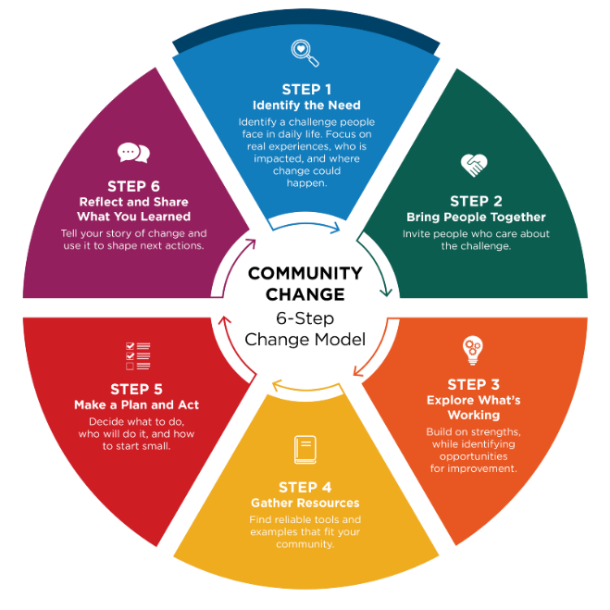
Community champions help bring priorities to light through conversation and observation.

Identifying a need means naming something that makes it harder for people to eat well, access healthy food, or be physically active. You can uncover needs by observing your community, having conversations, and listening to what people care about. A strong community need should:

- Support healthy eating, food access, and/or physical activity
- Affect many people, not just one individual
- Reflect what community members and staff are experiencing and saying
- Name the place or setting where improvement can happen

Support healthy eating, food access, or physical activity

Think about how the need connects to healthier food or opportunities to be active. For example, limited produce options at a local store or a lack of safe places to walk may signal an opportunity for improvement.

Ask:
What challenge or opportunity do you see that relates to eating well or being active?
If you could dream big and anything was possible, what would you change or improve?

Affect many people

A strong need should impact more than one person. Look for patterns or issues that several parents, students, staff members, or neighbors experience. If the need affects a group, it is more likely to create meaningful, lasting change.

Reflect community voices

Talk with staff, partners, community members, and program participants to understand what people are experiencing. Listening helps you learn why the need matters and what the benefits could be.
Open‑ended questions help people share more about their goals and challenges. They also build trust and help you understand the issue in their own words.

Examples of open‑ended questions:
- If things were working really well, what would that look like?
- What are your goals related to nourishing food and physical activity?
- What’s getting in the way of reaching these goals?
- What’s already going well that we can build on?
- What opportunities do you see for change?

Name the place or setting

Be clear about the space where change can happen. This could be a school, neighborhood park, food pantry, community garden, childcare center, workplace, or another local setting.
The clearer you are about what will change and where it will happen, the easier it is to understand the need and support the effort.

Ask yourself:
Where does this need show up?
What specific improvement could make a difference?

Step 1 Worksheet: Identify the Need

Use this worksheet to identify a priority need that reflects lived experience, affects many people, connects to healthy eating/food access or physical activity, and clearly names the setting where change can happen. Community Champions can help surface insights and mobilize early conversations.

1) Choose your focus setting

Where is this need showing up? (choose one)
- A classroom or group of people
- A school building or district or community program site
- An early childhood setting (center, home-based, classroom)
- A community organization (nonprofit, coalition, agency)
- A healthcare setting (clinic, WIC, hospital program)
- A food resource setting (pantry, market, distribution site)
- A workplace or staff team
- A lactation or breastfeeding support setting (lactation room/space, staff/parent supports)
- Other: _____________________________________________________________

2) What challenges or opportunities are you noticing?

Be specific and connect to healthy eating, food access, or physical activity. Example: “Kids sit for long periods,” “Families don’t know where to start,” “Healthy foods are hard to access,” “Staff need support for breastfeeding/lactation.”

What we’re noticing: _____________________________________________________

3) How do you know this is a need and affects many people?

Choose all that apply:
- Staff observations
- Participant/client feedback
- Community feedback
- Data (surveys, participation, incident logs, program data, etc.)
- Policy/compliance requirements
- Other: _____________________________________________________________

4) Why does this matter to our community?

If this issue improved, what would be different?
For participants/community: ______________________________________________
For staff/operations: ____________________________________________________

5) What community voices or perspectives informed this need?

Choose all that apply:
- Community members directly affected
- Staff or volunteers
- Families or caregivers
- Neighborhood or community groups
- Partners or collaborating organizations
- Community leaders
- Data that reflects community experience (Community Health Needs Assessment, local data, etc.)

6) What are the benefits we hope to see?

Choose all that apply:
- Increased physical activity (more movement and less sitting)
- Improved access to nourishing food (food access or food/nutrition security)
- Healthier food and beverage choices
- Improved health and wellness outcomes for participants and families
- Reduced barriers to healthy choices in the organization or setting
- Stronger routines, systems, and supports that make healthy choices easier
- Other: ______________________________________________________________

7) Community champion contribution (who + how)

Which champions helped identify this need and how did they contribute? (Mobilize, Connect): ___________________________________________________________________

About MSU Extension’s Community Change Model
This Guide and Worksheet is part of a larger Six-Step Community Change Model Toolkit that assists community champions in supporting communities to make thoughtful, lasting improvements that help people choose nourishing foods and stay active. Six simple steps guide desired change efforts by bringing people together, taking action, and sharing what was learned along the way.
See MSU Extension’s Community Change Hub for curated resources and topic-specific guidance that support change efforts related to championing school wellness, food access, early childhood health, and active communities.

